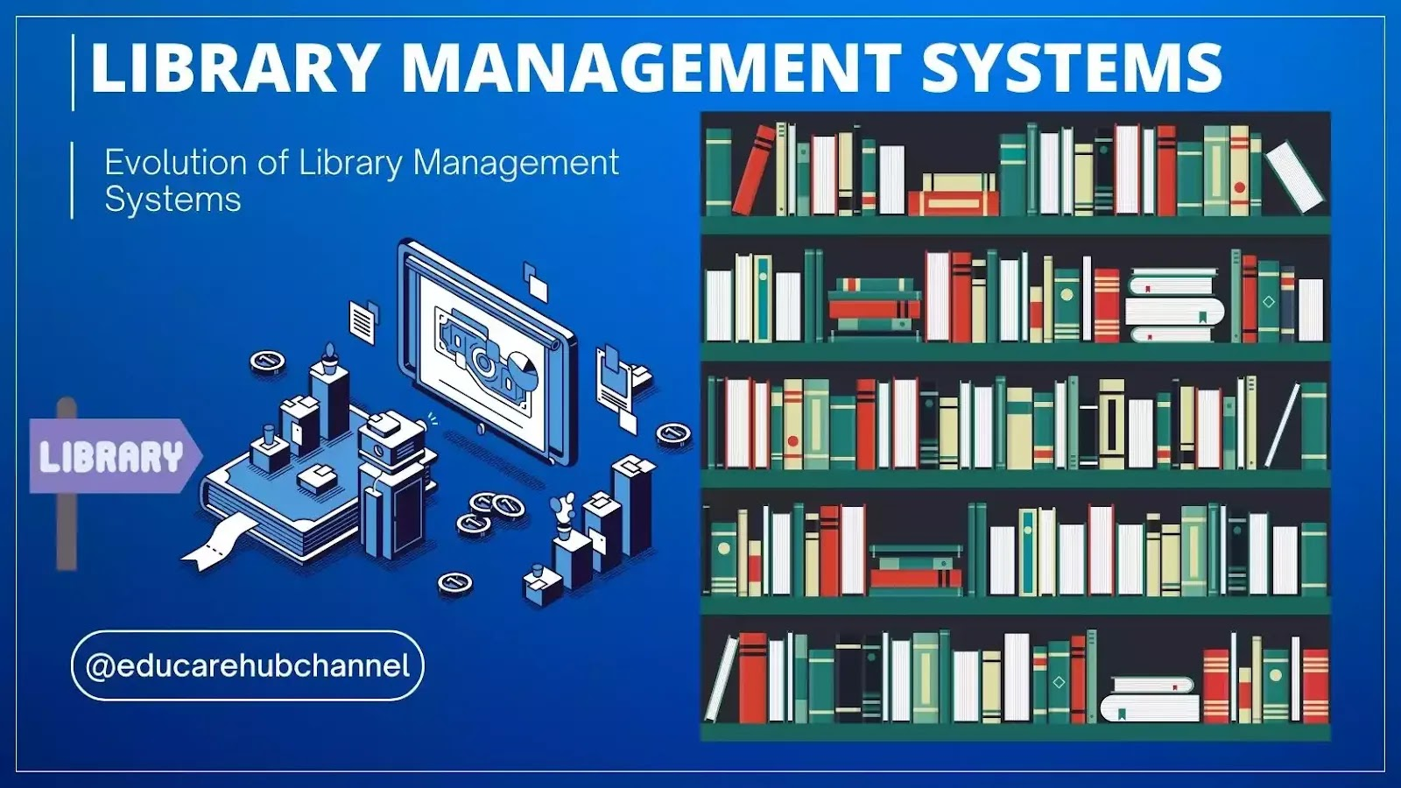
Library management
System in java
Review-2
- Library management System in java
code to ode
-team name
Team member -Section 48
1. Nitish Tiwari(leader)
nitish.24scse1410220@galgotiasuniversity.ac.in
2. Rahul Kumar Patak
rahul.24scse1410259@galgotiasuniversity.ac.in
3. vishal Nagar
vishal.24scse1410248@galgotiasuniversity.ac.in

1. Core Feature Implementation
Purpose
To ensure that all major functionalities required by the project are fully completed, functional, and aligned with the original specifications.
CODE
- import java.util.*;
- import java.io.*;

- // Book class
- class Book {
- int id;
- String title;
- String author;
- boolean isIssued;

- public Book(int id, String title, String author) {
- this.id = id;
- this.title = title.trim();
- this.author = author.trim();
- this.isIssued = false;
- }

- public void issueBook() {
- isIssued = true;
- }

- public void returnBook() {
- isIssued = false;
- }

- @Override
- public String toString() {
- return id + ". " + title + " by " + author + (isIssued ? " [Issued]" : " [Available]");
- }
- }

- public class LibraryManagement {
- static ArrayList<Book> books = new ArrayList<>();
- static Scanner sc = new Scanner(System.in);
- static int bookIdCounter = 1;

- public static void main(String[] args) {
- int choice = -1;

- do {
- System.out.println("\n==== Library Management System ====");
- System.out.println("1. Add Book");
- System.out.println("2. View Books");
- System.out.println("3. Issue Book");
- System.out.println("4. Return Book");
- System.out.println("5. Search Book");
- System.out.println("6. Export Book List to File");
- System.out.println("7. Exit");
- System.out.print("Enter your choice: ");

- try {
- choice = Integer.parseInt(sc.nextLine());
- switch (choice) {
- case 1 -> addBook();
- case 2 -> viewBooks();
- case 3 -> issueBook();
- case 4 -> returnBook();
- case 5 -> searchBook();
- case 6 -> exportToFile();
- case 7 -> System.out.println("Exiting... Thank you!");
- default -> System.out.println("Invalid choice! Enter 1 to 7.");
- }
- } catch (NumberFormatException e) {
- System.out.println("Invalid input! Please enter a number.");
- }
- } while (choice != 7);
- }

- static void addBook() {
- System.out.print("Enter book title: ");
- String title = sc.nextLine().trim();
- System.out.print("Enter author name: ");
- String author = sc.nextLine().trim();

- if (title.isEmpty() || author.isEmpty()) {
- System.out.println("Title or Author cannot be empty.");
- return;
- }

- Book book = new Book(bookIdCounter++, title, author);
- books.add(book);
- System.out.println("Book added successfully.");
- }

- static void viewBooks() {
- if (books.isEmpty()) {
- System.out.println("No books available.");
- } else {
- System.out.println("\n--- Book List ---");
- for (Book b : books) {
- System.out.println(b);
- }
- }
- }

- static void issueBook() {
- int id = getBookIdInput("Enter book ID to issue: ");
- Book b = getBookById(id);
- if (b == null) {
- System.out.println("Book not found.");
- return;
- }

- if (!b.isIssued) {
- b.issueBook();
- System.out.println("Book issued successfully.");
- } else {
- System.out.println("Book is already issued.");
- }
- }

- static void returnBook() {
- int id = getBookIdInput("Enter book ID to return: ");
- Book b = getBookById(id);
- if (b == null) {
- System.out.println("Book not found.");
- return;
- }

- if (b.isIssued) {
- b.returnBook();
- System.out.println("Book returned successfully.");
- } else {
- System.out.println("Book was not issued.");
- }
- }

- static void searchBook() {
- System.out.print("Enter keyword to search (title or author): ");
- String keyword = sc.nextLine().toLowerCase();

- boolean found = false;
- for (Book b : books) {
- if (b.title.toLowerCase().contains(keyword) || b.author.toLowerCase().contains(keyword)) {
- System.out.println(b);
- found = true;
- }
- }

- if (!found) {
- System.out.println("No matching book found.");
- }
- }

- static void exportToFile() {
- try (PrintWriter pw = new PrintWriter("BookList.txt")) {
- for (Book b : books) {
- pw.println(b);
- }
- System.out.println("Book list exported to BookList.txt");
- } catch (IOException e) {
- System.out.println("Error writing to file.");
- }
- }

- static Book getBookById(int id) {
- for (Book b : books) {
- if (b.id == id) {
- return b;
- }
- }
- return null;
- }

- static int getBookIdInput(String prompt) {
- while (true) {
- System.out.print(prompt);
- try {
- return Integer.parseInt(sc.nextLine());
- } catch (NumberFormatException e) {
- System.out.println("Invalid input. Enter a valid book ID.");
- }
- }
- }
- }

2. Error Handling & Robustness
Purpose
To prevent application crashes and improve user experience through proper handling of unexpected situations.
- Maintain detailed technical logs for debugging (without exposing sensitive information).
- Ensure the system continues to run safely even during unexpected errors.
- Implement fallback or recovery mechanisms (e.g., retry logic, default values).
- Avoid exposing stack traces or sensitive server information to end users.
- Test the application under edge cases and stress conditions.

- import java.util.Scanner;

- public class LibraryApp {
- public static void main(String[] args) {
- LibraryRepository repo = new LibraryRepository();
- LibraryService service = new LibraryService(repo);
- Scanner sc = new Scanner(System.in);

- while (true) {
- System.out.println("\n--- Library Management System ---");
- System.out.println("1. Add Book");
- System.out.println("2. Add Member");
- System.out.println("3. Issue Book");
- System.out.println("4. Return Book");
- System.out.println("5. Search Books");
- System.out.println("6. Exit");
- System.out.print("Enter choice: ");

- int choice = sc.nextInt();
- sc.nextLine(); // flush

- switch (choice) {
- case 1:
- System.out.print("Book ID: ");
- String bookId = sc.nextLine();
- System.out.print("Title: ");
- String title = sc.nextLine();
- System.out.print("Author: ");
- String author = sc.nextLine();
- service.addBook(bookId, title, author);
- break;

- case 2:
- System.out.print("Member ID: ");
- String memId = sc.nextLine();
- System.out.print("Name: ");
- String name = sc.nextLine();
- service.addMember(memId, name);
- break;

- case 3:
- System.out.print("Book ID: ");
- service.issueBook(sc.nextLine(), ask(sc, "Member ID: "));
- break;

- case 4:
- System.out.print("Book ID: ");
- service.returnBook(sc.nextLine());
- break;

- case 5:
- System.out.print("Keyword: ");
- service.searchBooks(sc.nextLine());
- break;

- case 6:
- System.out.println("Goodbye!");
- return;
- }
- }
- }

- private static String ask(Scanner sc, String msg) {
- System.out.print(msg);
- return sc.nextLine();
- }
- }

3. Integration of Components
- Perform integration testing to identify issues that unit tests may miss.
- Ensure that the UI reacts correctly to backend responses.
- Resolve dependency conflicts between modules (libraries, frameworks, or APIs).
- Use modular architecture to support scalability and maintainability.
- Maintain synchronization between connected components (e.g., UI state and backend state).
- Document integration points and APIs used.

4. Event Handling & Processing
- Optimize asynchronous operations using promises, async/await, or event-driven designs.
- Prioritize performance in scenarios involving real-time updates (e.g., chat, dashboards).
- Ensure event logic is debounced or throttled when necessary (search bars, scroll events).
- Avoid blocking the main thread with heavy operations.
- Test performance impact using profiling tools.
- Maintain clear separation of event definitions, handlers, and business logic.

5. Data Validation
- Protect against injection attacks (SQL injection, XSS, command injection).
- Verify data types, formats, length, and required fields.
- Ensure database integrity and enforce constraints.
General Validation Guidelines
- Use validation libraries or schemas (e.g., Joi, Yup, Laravel Validation, Django forms).
- Return clear error messages specifying what went wrong.
- Sanitize and normalize data before storing it.

6. Code Quality & Innovation
Purpose
To maintain a high standard of code that is readable, maintainable, efficient, and future-proof.
Details
- Write modular code using reusable functions, components, or services.
- Follow established coding standards (e.g., ESLint rules, PEP8 for Python).
- Use proper naming conventions for variables, classes, and methods.

- public class Book {
- private String id;
- private String title;
- private String author;
- private boolean isIssued;

- public Book(String id, String title, String author) {
- this.id = id;
- this.title = title;
- this.author = author;
- this.isIssued = false;
- }

- // Getters & Setters
- public String getId() { return id; }
- public String getTitle() { return title; }
- public String getAuthor() { return author; }
- public boolean isIssued() { return isIssued; }
- public void setIssued(boolean issued) { isIssued = issued; }
- }

7. Project Documentation
Purpose
To ensure clarity, maintainability, and ease of onboarding for developers and users.
Details
Technical Documentation
- Installation and setup instructions.
- Project architecture overview (diagrams optional).
- Explanation of each module, component, and workflow.
- API documentation if the project includes backend endpoints.
- Database schema and model explanations.
- Deployment instructions (local, staging, production).
User Documentation
- How to use the application (step-by-step guides).
- Feature descriptions with examples.
- Troubleshooting tips.
- Screenshots or visuals where appropriate.
Developer Documentation
- Coding standards and naming conventions.
- Git branching strategies.
- Environment variables and configuration guidelines.

BLOCKCHAIN TECHNOLOGY IN INFORMATION SECURITY AND PROVENANCE
Blockchain technology is quickly gaining interest in the library sector as it offers a strong way to improve data security, validate provenance, and guarantee the accuracy of information. Protecting sensitive data and ensuring the authenticity of digital information become increasingly important as the digital ecosystem develops and grows. Security of transactions is one of the main uses of blockchain in libraries. Secure transactions are made possible by the decentralized and unchangeable nature of blockchain, which encrypts every transaction and stores it in a distributed ledger that is impenetrable to tampering. This capability can be used by libraries to safely handle cash exchanges, membership renewals, and other financial transactions inside their systems. This increases stakeholder confidence and openness while also ensuring financial integrity. Additionally, libraries can effectively manage digital rights thanks to blockchain technology. Libraries may automate and enforce copyright conditions, license agreements, and access permissions for digital content with smart contracts. This minimizes unlawful access and usage while streamlining the administration of digital resources and guaranteeing that content is used in accordance with the granted permissions. Blockchain is also helpful in maintaining the integrity of digital archives, which is another important field. Libraries may confirm the legitimacy and provenance of digital materials by using blockchain to timestamp and create an irreversible record of archival procedures and metadata. This unchangeable record is a potent weapon against data manipulation, guaranteeing that the historical and cultural value of digital archives endures and is reliable.

CONCLUSION

The way libraries serve their users has been transformed by the revolutionary possibilities of digital tools, mobile apps, beacon technology, and open access efforts. These developments show how libraries can adapt to a world that is becoming more and more digital, from increasing user interaction to guaranteeing the longevity of digital resources. Libraries' fundamental goal of offering inclusive, high-quality resources for learning, research, and enrichment is clearly still unwavering, even as they adapt and adopt new technologies and techniques. Libraries enable people to interact creatively with knowledge, collaborate more efficiently, and obtain information with ease by utilizing these technologies. This is the library of the future, and it runs on technology. Librarians are utilizing the newest technological advancements, such as cloud- hosted library solutions and artificial intelligence, to enhance user experience and remain competitive. Libraries may revolutionize the old library model and unleash new possibilities by embracing digital resources, implementing library automation, and utilizing electronic data interchange. Libraries are developing and adjusting to the shifting environment of information access and storage with the help of these and other trends in library technology.

